INVITATION
To： From：
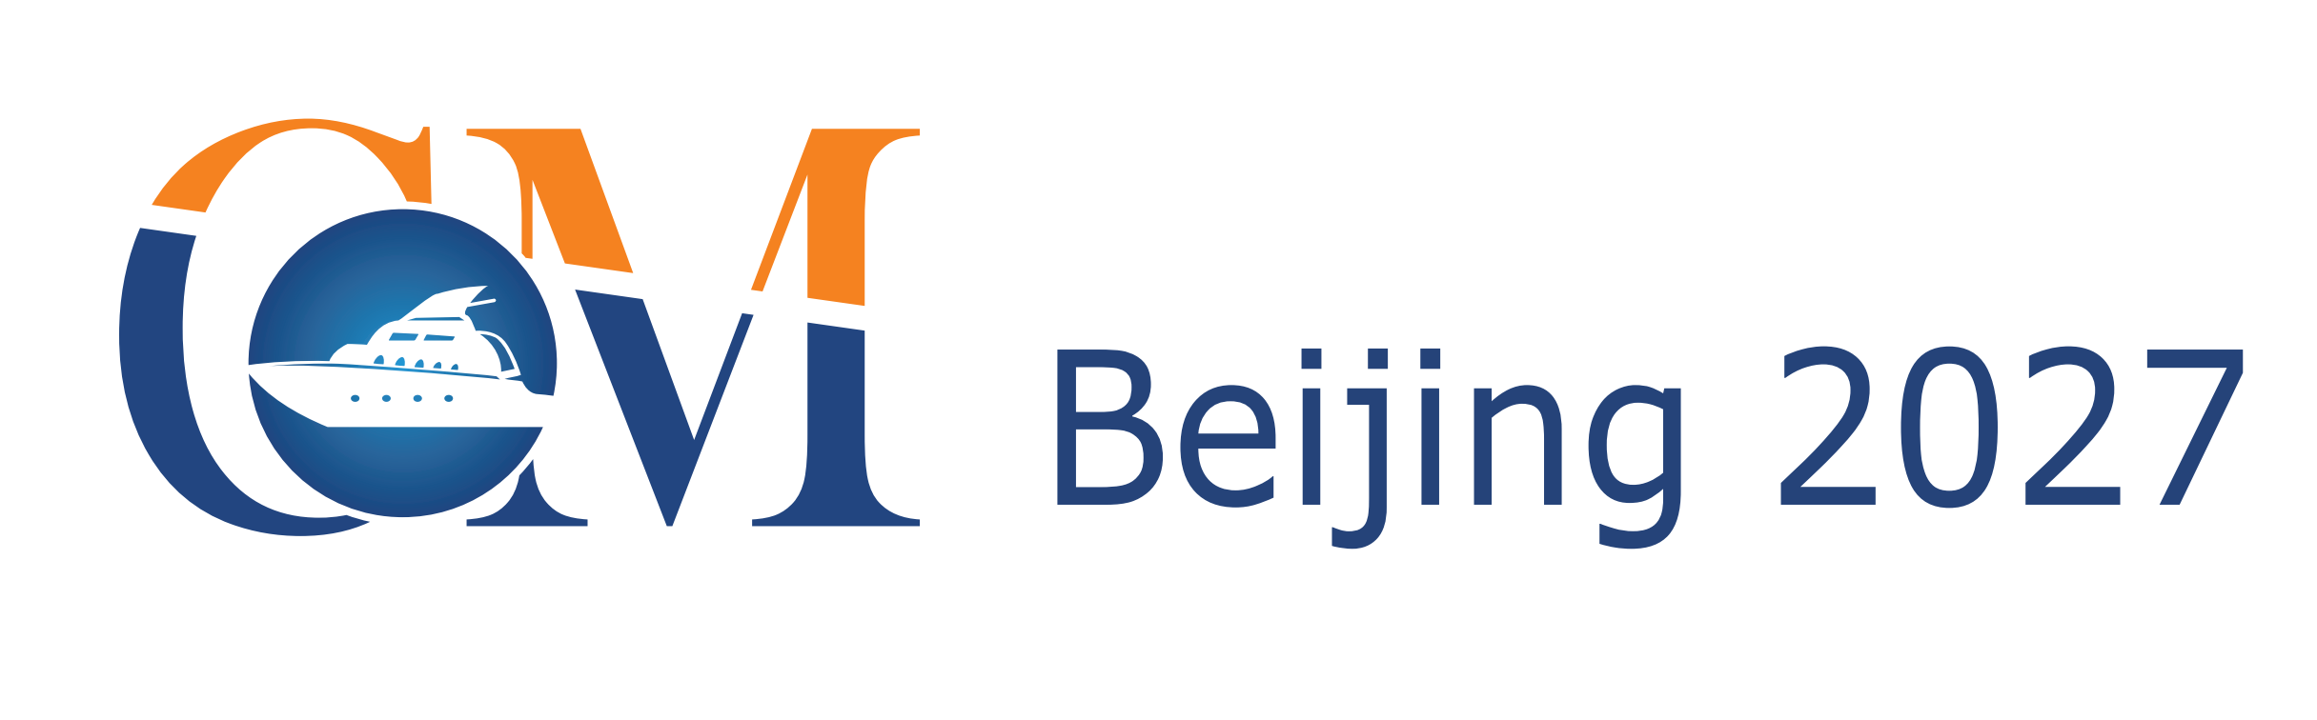
The 17th Beijing International Offshore
Engineering Technology & Equipment Exhibition
March 17-19, 2027 China International Exhibition Center (Shunyi Hall), Beijing

The Leading Offshore Event in Asia

Hosted by
China Association of the National Shipbuilding Industry
The Chinese Society of Naval Architects and Marine Engineers
Zhenwei International Exhibition Group

Organized by
Beijing Zhenwei Exhibition Co., Ltd.
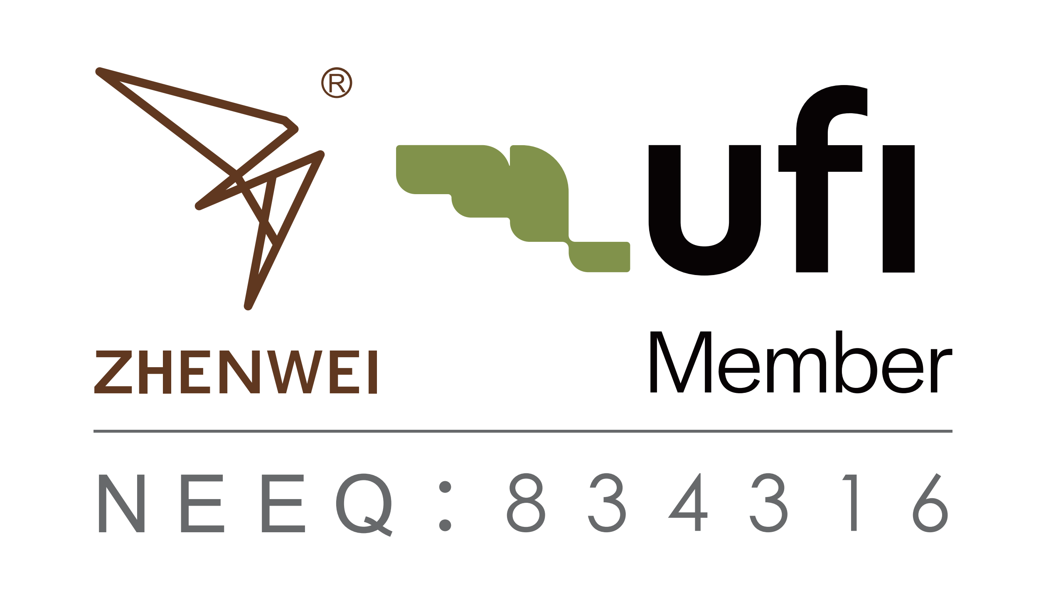

Concurrent Exhibitions:
cippe ciooe CIPE CING Expec cisge

Exhibition Profile
The 17th Beijing International Offshore Engineering Technology & Equipment Exhibition (CM 2027) will be held on March 17-19,2027 at Shunyi Hall, Beijing，concurrently held with China International Petroleum & Petrochemical Technology and Equipment Exhibition(cippe).CM2027 is one of the most influential and comprehensive exhibitions, covering offshore engineering, offshore oil and gas, onshore oil and gas. It welcomed 2,000 exhibitors, 18 National Pavilions and 180,000 professional visitors from 81 countries and regions worldwide in the year of 2026, achieving an exhibition floor space of above 120,000 square meters.
CM2026 had an attendance of 18 international pavilions from USA, Germany, UK, France, Canada, Denmark, Italy, Russia, Korea etc. The well-known enterprises of ExxonMobil, Rosneft. Schlumberger, Bake Hughes, DNV/GL, RS, National Oil Varco, Caterpillar, MTU, Cummins, GE, Schneider, Honeywell, Atlas, Huisman, API, 3M, E+H, ARIEL, KSB, PPG, Hempel, International Maritime Services, have all participated in the event.
Moreover, CM2027 has received great support from the domestic exhibitors, such as CNPC Pavilion, Sinopec Oil Engineering Machinery Company, CNOOC, CSSC, CCS, CIMC RAFFLES,RG Petro-machinery (Group) Co.,Ltd, HONGHUA, JEREH, KERUI, SANY, Tidfore, L&H, JULI Sling, HBP,Tidfore, JERRYWON,Ocean King Lighting,Douson Group, ANTON, JUNMA, SHENKAI, Tianjin LILIN and etc.
The professional buyers are from CNPC, SINOPEC, CNOOC, Overseas Project Department of CNODC, China Petrolum Pipeline Bureau, Sinotrans & CSC Holdings Co. Ltd, COSCO, BP, Saudi Aramco, Shell, Total, Gazprom, Rosneft, ConocoPhillips, Statoil, Petrobras, Schlumberger, Bake Hughes, Halliburton, Weatherford, Transocean,Chevron, etc,together with many other professional visitors from Brazil, Ukraine, Malaysia, Sudan, Nigeria and so on.
Offshore engineering equipment is a national strategic asset for maritime development. During the 15th Five-Year Plan period, it will serve as a core carrier for new quality productive forces and a new growth engine of the marine economy, with a clear requirement to consolidate and enhance the advantages of the marine equipment manufacturing industry.
Aiming at utilizing the international vision of Beijing, creating a highly efficient platform for showcasing the latest technologies and products in offshore engineering industry, connecting buyers with suppliers, and assisting exhibitors in exploring business opportunities in China and world market, CM will successfully bridge you to China’s offshore engineering industry. Let us set sail on a successful journey with CM Beijing 2027—the great event that you do not want to miss out!
Who Should Exhibit
(If you are a supplier of any of the products or service shown below, please book a stand right away)
- Offshore oil & gas exploration, exploit and production equipment
- Offshore geophysical exploration , well logging and drilling
- Offshore drilling platform associated equipment
- Classification Society
- Offshore platform module
- Oil and gas storage and transport equipment
- Design, research institute
- Oilfield services
- Work boat and offshore support vessel
- LNG/LPG/LEG ship
- Power and control equipment
- Steel structure
- Explosion- proof equipment
- Electrical & electronic instruments
- Pipelines, valve, pump
- Examination, repair, maintenance and management equipment
- Fire and alarm equipment,articles for safety and labor protection
- Special vehicle, helicopter and drone
- Technology and material for anti- corrosion
- Technology and equipment for ocean wind power
- Ocean exploration, underwater processing
- Water treatment technology and equipment
- Flammable ice exploration, exploit technology and equipment
- Environment protection and safety
- Marine new materials
- Remote detection
- Communication, Management information system
- Publication/Technical/Training

Technical Seminar
A series of technical seminars will be held during the exhibition so as to maximally meet participants’ requirement for technical communication and products launch, as well. Each seminar lasts for one hour and cost CNY 12,000 which includes the expenses of meeting room and the rents of relevant equipment.

Exhibition Costs
Exhibition Space | Shell Scheme:  Price: CNY 30,000/9SQM; Regular size : 3m×3m.  This option includes back & inside walls, carpet, lintel board, one consulting table, two chairs, two lights and one power socket (220V, 5A).
Exhibition Space | Raw Space:  Price: CNY 3,200/SQM. (Mini.36sqm).  Empty exhibition space for exhibitor to customize booth design and construction. The exhibitors shall not choose a contractor that which is not appointed to design and or construct their special design.
Exhibitor Service | Additional Exhibitor Service  Price: CNY 1,200/person (It includes lunches, beverages, opening banquet, gifts, etc.)
Exhibition Catalogue Ad. | Front Cover: CNY 36,000 Inside Back Cover: CNY 22,000  Back Cover: CNY 30,000 Head Page: CNY 25,000  Inside Front Cover: CNY 25,000 Colored Inside Page: CNY 12,000
Technical Seminar | A series of technical seminars will be held during the exhibition so as to maximally meet participants’ requirements for technical communication and products launch as well.  Technical Seminar (Conference Room)  Price: CNY12,000/Session  New Product/Technology Promotion Session (Exhibition Hall Seminar Area)  Price: CNY32,000/30minutes
Exclusive Sponsor | Banquet Sponsor: CNY360,000  With around 600 participants, including VIPs, exhibitors, summit delegates, industrial leaders and professional purchasers, etc., the Banquet will offer you with an excellent opportunity for market campaign.  Gift Sponsor: CNY300,000  All the sponsored gifts will be distributed to VIP guests. It is an efficient way to show the strength of the sponsor, to promote brand awareness and to enhance market position as well.  Visitor Guide Sponsor: CNY96,000(Back cover advertisement)
Media Promotion | Pre-show Promotion: CNY 2,000/time  Post-show Promotion: CNY 2,000/time  During the show promotion: CNY 7,000/time
Photography Service | Photography and video  Price: CNY6,000/day
Live Broadcasting | Exhibition visiting live broadcasting  Price: CNY5,000/session (5-20minutes)
Live Broadcasting | Customized exhibition live broadcasting  Price: CNY50,000/day

More Sponsorship Opportunities, please contact with the CM organizational committee.

Organizer:Beijing Zhenwei Exhibition Co.,Ltd
Add: Zhenwei Exhibition Building, Building III13, International Enterprise Avenue, Yard 1, Jinghai
5th Road, Tongzhou District, Beijing
Tel: +86-10- 56176945 Fax: +86-10-5617 6998
Web: www.chinamaritime.com.cn E-mail: cm@zhenweiexpo.com

APPLICATION FORM
The 17th Beijing International Offshore Engineering Technology & Equipment Exhibition
March 26-28, 2027 China International Exhibition Center (Shunyi Hall), Beijing
Please fill out the form below and then send it back to the organizer via fax or e-mail.
Company Name:
Address: Country: Postal/Zip code:
Contact (Mr. / Ms.): Position:
Mobile: TEL: FAX:
Website: E-mail:
Main products/exhibits (English):
Exhibition Space
□ Shell scheme: SQM (CNY30, 000 / 9 SQM)
Preferred booth numbers: Fee:
- Raw space: SQM (CNY3, 200 / SQM minimum 36 SQM)
Preferred booth numbers: Fee:
Sponsorship & Advertisement
- Exhibition Catalogue Ad.
□Front Cover CNY36,000 □Inside Front Cover CNY25,000 □Head Page CNY25,000 □Back Cover CNY30,000 □Inside Back Cover CNY22,000 □Colored Inside Page CNY12,000
□ Show Daily:
□ Full page US$19,375 per insertion □Half page US$9,688 per insertion
- Technical Seminar
□Technical Seminar CNY12,000/Session
□New Product/Technology Promotion Session CNY32,000/30minutes
- Exclusive Sponsor
□Banquet Sponsor: CNY360,000 □Gift Sponsor: CNY300,000
□Visitor Guide Front Cover: CNY180,000 □Visitor Guide Sponsor: CNY960,000
□ Media Promotion
□Pre-show Promotion: CNY 2,000/time □Post-show Promotion: CNY 2,000/time
□During the show promotion: CNY 7,000/time
□ Photography Service
□Photography and video CNY6,000/day
□ Live Broadcasting
□cippe Discoveries Livestream CNY5,000/session □Customized live broadcasting CNY50,000/day
□ Additional Exhibitor Service CNY 1,200/person Person(s)
Total fee: Payment Date:
Beijing Zhenwei Exhibition Co., Ltd.  Tel: +86 10 5617 6945  E-mail: cm@zhenweiexpo.com  Contact: CM | Company Name:  Signature & Stamp:
Special Attention:
1.Please remit the total participation fee to the account appointed by the organizer within 10 business days upon receipt the confirmation letter; 2. Booking received without this deposit will not be confirmed; 3.The payment cannot be refunded if the registered exhibitors do not exhibit for its own reason; 4.The exhibiting products should meet the exhibit scope and theme, and should not infringe; 5.intellectual property rights, otherwise the exhibitors should bear the full legal responsibility.
CM 2027 Target Visitors Programme
Exhibitor Name
Website
Company Profile
Products & Technology to be Showcased
What kind of companies you are keenly interested in meeting at CM2027? | e.g. oil and gas field units, oil production plants, exploration and development companies, drilling engineering companies, etc.
Please name some companies you haven’t established business relations but hope to meet at CM2027 (the more the better).
Please name some companies you are already in cooperation with and hope to meet at CM2027 (the more the better).
Note: If the companies you would like to meet are giants like CNPC, SINOPEC, etc. Please name the branch name, departments or main business.

