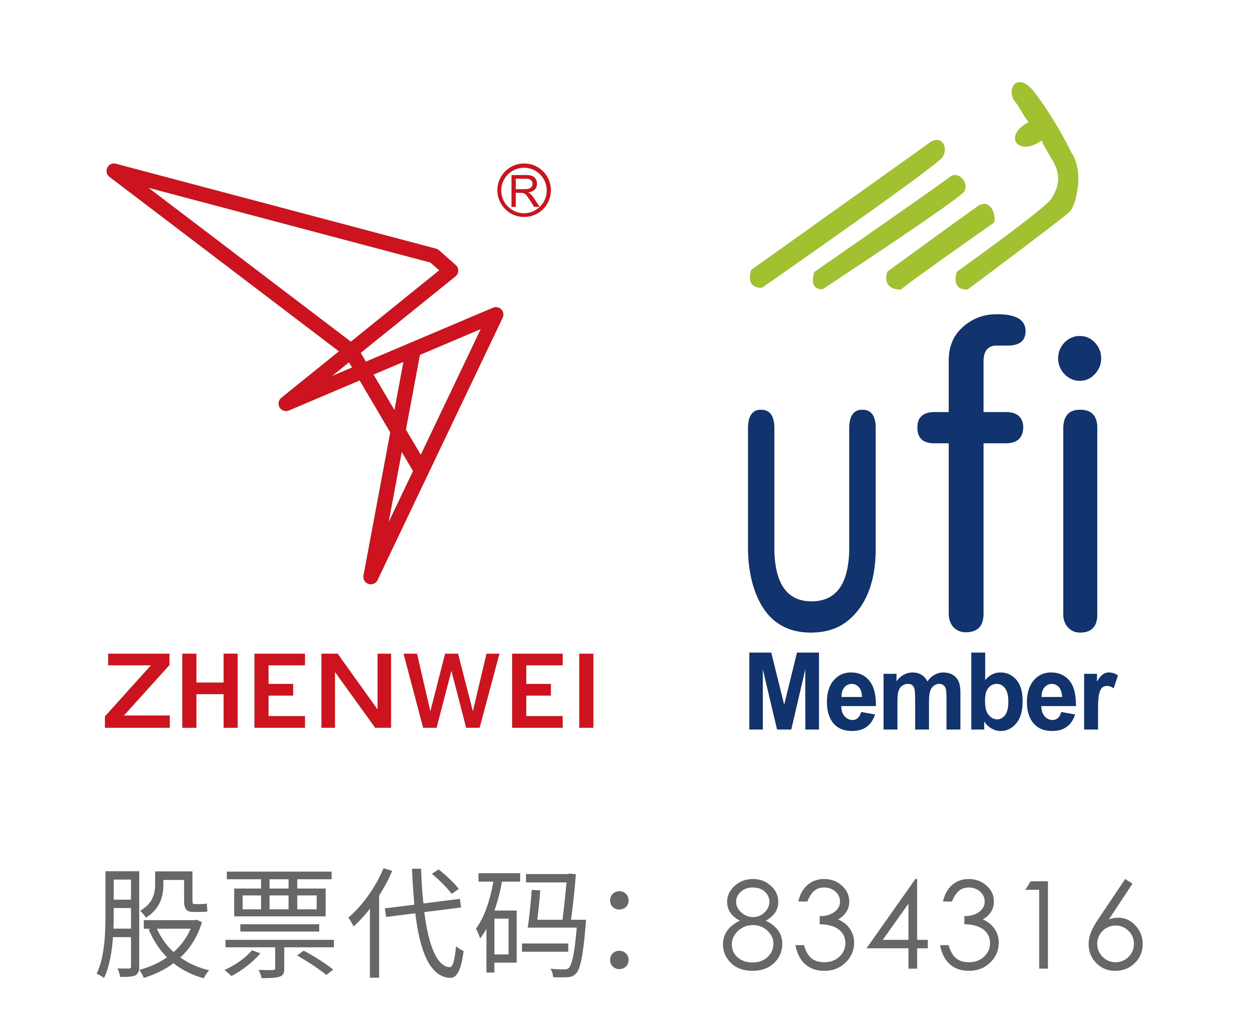
INVITATION
To： From:


The 26th China International Petroleum & Petrochemical Technology and Equipment Exhibition

March 25-27, 2026
New China International Exhibition Center, Beijing

The Annual World’s Leading Event for Oil & Gas Industry
2,000 Exhibitors from 75 Countries and Regions
52 Exhibitors from Fortune Global 500
18 International Pavilions
120,000m2 Exhibition Space
180,000 Person-time Professional Visitors

Organizers
Zhenwei International Exhibition Group
Beijing Zhenwei Exhibition Co., Ltd.

Supporters
China Petroleum and Chemical Industry Federation
China Petroleum & Petrochemical Equipment Industry Association
The Explosion Proof Electric Apparatus Branch of the Electric Equipment Industry Association of China
cippe2026 Profile
cippe (China International Petroleum & Petrochemical Technology and Equipment Exhibition) is a world’s leading event for oil & gas industry, annually held in Beijing. It is a great platform for connection of business, showcasing of advanced technology, collision and integration of new ideas; with the power to convene industry leaders, NOCs, IOCs, EPCs, service companies, equipment and technology manufacturers and suppliers under one roof across three days.
cippe Beijing will welcome the attendance of international pavilions such as USA, Germany, UK, France, Canada, Italy, South Korea, Russia, and Iran etc. And is expected to welcome well-known domestic and international enterprises including Ministry of Oil (Iraq), KOGAS, Caterpillar, Schlumberger, Cummins, DuPont, KTR, Rolls-Royce Power Systems, Danfoss, Kongsberg, Allison, Ariel, Balluff, Atlas Copco, Huisman, CNPC, SINOPEC, CNOOC, CASC, CASIC, CRRC, XCMG, HONGHUA, JEREH, KERUI, RG PETRO-MACHINERY GROUP, CITIC Heavy Industries, Hilong Group, Weichai, ZPEC, Anton, Dong Fang Xian Ke, Shanghai Shenkai, BESTEBIT, PetroKH, Haimo Technologies, Petro-king, West Petro, Baowu, Daye Special Steel, Guoxing Huijin, etc., to show up with frontier innovation and application.
In 2025, it welcomed CNPC, Sinopec and CNOOC delegations such as CPECC, CKCEC, PetroChina Exploration and Development Company, China Petroleum Pipeline Bureau, Dagang Oilfield, North China Oilfield, Daqing Oilfield, Bohai Oilfield, SPIC, SSC, Sinopec Petroleum Engineering Corporation, Shengli Oilfield, Jianghan Oilfield, CNOOC Procurement Center, Clean Energy Branch of CNOOC Energy Development Company, COSL, CNOOC Gas & Power Group, etc., and also other domestic delegations from provincial energy administrations, PipeChina, Yanchang Petroleum, CSSC, CNNC, Sinochem, China Shenhua, China Coal, Beijing Gas, Tianjin Gas, ENN, Wison, ZhenHua Oil, etc. Besides, cippe2026 welcomed overseas visitor delegations from Rosneft, Gazprom, Lukoil, Tatneft, NIOC, KazMunayGas, Saudi Aramco, PDVSA, Petronas, SOCAR, PTTEP, Pertamina, Pan American Energy, SERTECPET, Shell, Total, Chevron, Eni, Eriell Group, Halliburton, Technip Energies, Fluor, Petrofac, etc.
cippe 2026 will offer you an excellent platform for seizing the opportunity to enhance and increase your market share in China and the world, display products and services, network with existing and new clients, forge partnerships and discover potential opportunities.
Look forward to greeting you at cippe 2026 from 25 to 27 March at NCIEC, Beijing.

Key Concurrent Events
- The Fourth Presidents Forum of Petroleum Technology and Equipment Institutes & The 18th
- Business Matchmaking Meeting
- International Oil, Gas and Energy Promotion Conference
- h International Petroleum & Natural Gas Conference
- cippe Gold Innovation Award
Co-located Exhibitions
Offshore | The 26th Beijing International Offshore Oil & Gas Exhibition
Pipeline | The 26th Beijing International Oil & Gas Pipeline, Storage and Transportation Exhibition
Natural Gas | The 16th Beijing International Natural Gas Technology & Equipment Exhibition
Marine  Hydrogen  Gas  Trenchless  QHSE  Geothermal | The 16th Beijing International Offshore Engineering Technology & Equipment Exhibition  2026 Beijing International Hydrogen Technology & Equipment Exhibition  2026 Beijing International Gas Applications and Technical Equipment Exhibition  Beijing International Underground Engineering Construction & Trenchless Exhibition  Beijing International Petroleum and Petrochemical Safety Production Exhibition  China International Geothermal Energy Development Technology & Equipment Exhibition
Exhibition Schedule
Registration & Setting up: | March 23-24, 2026
Exhibition Opening: | March 25-27, 2026
Closing & Dismantling: | Begin at 14:00pm, March 27, 2026

Exhibit Profile
◻ Oil & gas exploration, exploit, and production equipment
◻ Geophysical exploration, well logging and drilling technology and equipment
¨ Well completion technology and equipment
◻ Marine engineering technology and equipment
◻ Natural gas technology and equipment
◻ Automation technology equipment, instruments and meters
◻ Oil and gas field surface engineering technology and equipment
◻ Petroleum & petrochemical equipment and manufacturing
◻ Industrial explosion-proof products
◻ Oil and gas pipeline engineering
◻ Underground engineering and trenchless technology and equipment
◻ Power systems, power generation and supply
◻ Oil and Gas Storage & Transportation
◻ Oilfield Special Vehicle
◻ Electrical & electronic equipment, cable and electric wire
◻ Oil refining technological process and equipment
◻ Petrochemical process and technology
◻ Examination & repair, maintenance, and management
◻ Fluid control equipment- Compressor, Pump, Blower and Valve
◻ Pressure Vessels
◻ Oil and lubricating oil technology and equipment
◻ Petrochemical products and advanced material
◻ Refueling station equipment
◻ Environmental protection and energy conservation
◻ Fire and alarm equipment, articles for industrial safety and labor protection
◻ Anti-corrosion technology and material, industrial rinsing
◻ Packing, sealing, gasket, fastener, bearing
◻ Digital solutions for oil and gas industry
◻ Communications and information technology
◻ Hydrogen technology and equipment
◻ Certification, consulting services
◻ Scientific research and laboratory in petroleum & petrochemical industry
Exhibiting Costs
Exhibition Space | Shell Scheme:  Price: CNY 30,000/9SQM (W1\W2); Regular size: 3m×3m.  This option includes back & inside walls, carpet, lintel board, one consulting table, two chairs, two lights and one power socket (220V, 5A).
Exhibition Space | Raw Space:  Price: CNY 3,200/SQM. (Mini.36sqm) (W1\W2).  Empty exhibition space for exhibitor to customize booth design and construction. The exhibitors shall not choose a contractor that which is not appointed to design and or construct their special design.
Exhibitor Service | Additional Exhibitor Service  Price: CNY 1,200/person (It includes lunches, beverages, gala dinner, gifts, etc.)
Exhibition Catalogue Ad. | Front Cover: CNY 36,000 Inside Back Cover: CNY 22,000  Back Cover: CNY 30,000 Head Page: CNY 25,000  Inside Front Cover: CNY 25,000 Colored Inside Page: CNY 12,000
Technical Seminar | A series of technical seminars will be held during the exhibition so as to maximally meet participants’ requirements for technical communication and products launch as well.  Technical Seminar (Conference Room)  Price: CNY12,000/Session  New Product/Technology Promotion Session (Exhibition Hall Seminar Area)  Price: CNY32,000/30minutes
Exclusive Sponsor | Banquet Sponsor: CNY360,000  With around 600 participants, including VIPs, exhibitors, conference delegates, industrial leaders and professional purchasers, etc., the Banquet will offer you with an excellent opportunity for market campaign.  Gift Sponsor: CNY300,000  All the sponsored gifts will be distributed to VIP guests. It is an efficient way to show the strength of the sponsor, to promote brand awareness and to enhance market position as well.  Visitor Guide Sponsor: CNY96,000 (Back cover advertisement)
Media Promotion | Pre-show Promotion: CNY 2,000/time  Post-show Promotion: CNY 2,000/time  During the show promotion: CNY 7,000/time
Photography Service | Photography and video  Price: CNY6,000/day
Live Broadcasting | cippe Discoveries Livestream  Price: CNY5,000/session (5-20minutes)
Live Broadcasting | Customized live broadcasting  Price: CNY50,000/day
More Sponsorship Opportunities, please contact with the cippe Organizing Committee.

Organizer: Beijing Zhenwei Exhibition Co., Ltd.
Add: Zhenwei Exhibition Building, Building III13, International Enterprise Avenue, Yard 1, Jinghai 5th Road, Tongzhou District, Beijing
Tel: +86 10 5617 6968/58 Fax: +86 10 5617 6998
http://www.cippe.com.cn
Application Form
The 26th China International Petroleum & Petrochemical Technology and Equipment Exhibition
March 25-27, 2026 New China International Exhibition Center, Beijing
Please fill out the form below and then send it back to the organizer via fax or email.
Company Name:
Address: Country: Postal/Zip code:
Contact (Mr. / Ms.): Position:
Mobile: TEL: FAX:
Website: E-mail:
Main products/exhibits (English):
Exhibition Space
□ Shell scheme: SQM (CNY30, 000 / 9sqm)
Preferred booth numbers: Fee:
- Raw space: SQM (CNY3, 200 / SQM minimum 36 SQM)
Preferred booth numbers: Fee:
Sponsorship & Advertisement
- Exhibition Catalogue Ad.
□Front Cover CNY36,000 □Inside Front Cover CNY25,000 □Head Page CNY25,000 □Back Cover CNY30,000 □Inside Back Cover CNY22,000 □Colored Inside Page CNY12,000
- Show Daily:
□ Full page US$19,375 per insertion □Half page US$9,688 per insertion
- Technical Seminar
□Technical Seminar CNY12,000/Session
□New Product/Technology Promotion Session CNY32,000/30minutes
- Exclusive Sponsor
□Banquet Sponsor: CNY360,000 □Gift Sponsor: CNY300,000
□Visitor Guide Front Cover: CNY180,000 Visitor Guide Back Cover: CNY96,000
□ Media Promotion
□Pre-show Promotion: CNY 2,000/time □Post-show Promotion: CNY 2,000/time
□During the show promotion: CNY 7,000/time
□ Photography Service
□Photography and video CNY6,000/day
□ Live Broadcasting
□cippe Discoveries Livestream CNY5,000/session □Customized live broadcasting CNY50,000/day
□ Additional Exhibitor Service CNY 1,200/person Person(s)
□ Presidents Forum of Petroleum Technology and Equipment Institutes & International Petroleum &
Natural Gas Conference, attendee registration: CNY3,000/person (including lunch, gala dinner, conference brochures) Person(s), Total Fee:
Total fee: Payment Date:
Special Attention:
1.Please remit the total participation fee to the account appointed by the organizer within 10 working days upon receipt of the confirmation letter; 2.Booking received without payment will not be confirmed; 3.The payment wouldn’t be refunded if the registered exhibitors canceled for their own reasons; 4.The exhibiting products should meet the exhibit scope and theme, and should not infringe intellectual property rights, otherwise the exhibitors should bear the full legal responsibility and bear any losses caused to the organizer; 5.Exhibitors shall not choose a stand contractor that is not designated by the organizer. No contractors are allowed to enter the venue except for the designated ones.
Beijing Zhenwei Exhibition Co., Ltd.  Tel: +86 10 5617 6968/58  E-mail:  Contact: | Company Name:  Signature & Stamp:
cippe2026 Target Visitors Programme

Exhibitor Name
Website
Company Profile
Products & Technology to be Showcased
What kind of companies you are keenly interested in meeting at cippe2026? | e.g., oil and gas field units, oil production plants, exploration and development companies, drilling engineering companies, etc.
Please name some companies you haven’t established business relations but hope to meet at cippe2026 (the more the better).
Please name some companies you are already in cooperation with and hope to meet at cippe2026 (the more the better).
Note: If the companies you would like to meet are giants like CNPC, SINOPEC, etc. Please name the branch name, departments or main business.

