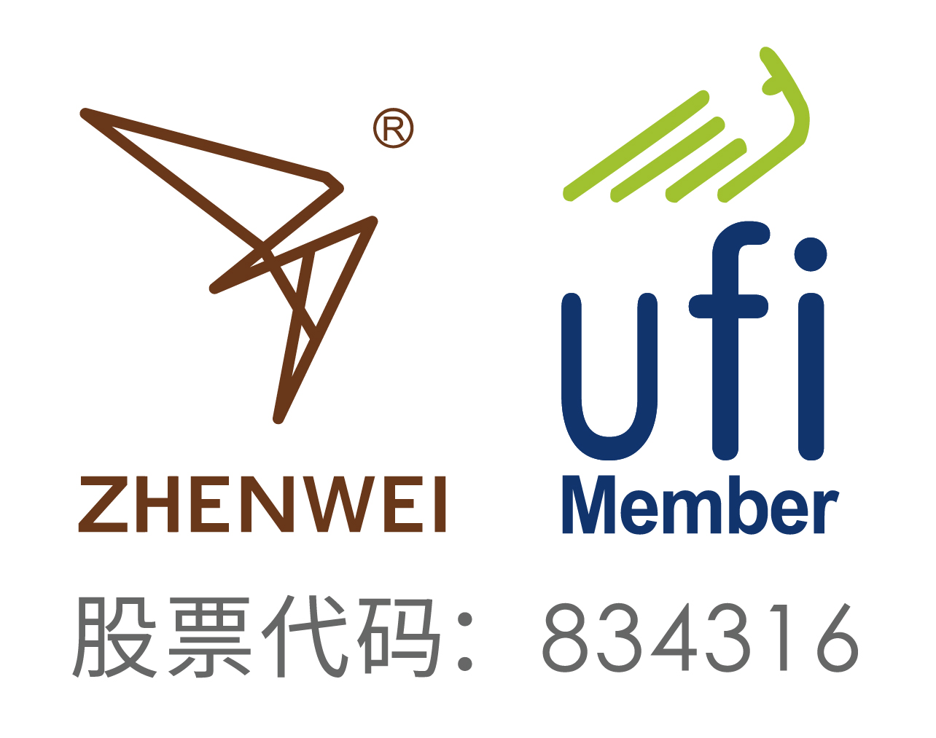
INVITATION
To: From：


The 16th Beijing International Natural Gas Technology & Equipment Exhibition

March 26th-28th, 2026
China International Exhibition Center (Shunyi Hall), Beijing
2,000 Exhibitors from 81 Countries and Regions
52 Exhibitors from Fortune Global 500
18 National Pavilions
120,000m² Exhibition Space
180,000 Professional Visitors

Organizer
Zhenwei International Exhibition Group
Beijing Zhenwei Exhibition Co., Ltd.

Supporter
Zigong clean automobile industry association

Exhibition Profile
With China’s rapid economic growth, it is of strategic importance to develop its natural gas industry. Statistics released by the International Energy Agency (IEA) show that China will demand 200 billion cubic meters of natural gas in 2016, 300 billion in 2020, and up to 500 billion in 2030. China will rank second only to the United States as one of the largest consumers of natural gas. Issued by the National Energy Administration of China, the 12th Five -Year Plan for Natural Gas Development specifies tasks including increasing energy supply, accelerating the construction of pipe networks, LNG terminals, and gas storage facilities, and the strengthening of independent scientific and technological innovations. Driven by these national-level policies and booming demand, China’s natural gas industry will enter into its “Golden Age” of natural gas development.

The 16th China International Natural Gas Technology & Equipment Exhibition (CING) will be held concurrently with the 25th China International Petroleum & Petrochemical Technology and Equipment Exhibition (cippe). This exhibition will welcome over 2,000 exhibitors from 81 countries and regions, 52 exhibitors from the top 500 enterprises, 18 international pavilions, and 180,000 professional visitors. The exhibition will achieve in reaching the capacity of the exhibition floor space of nearly 120,000 square meters.

Some of the 18 national pavilions included the participation of the United States, Germany, Great Britain, France, Canada, Denmark, Italy, Russia, Korea, and the Netherlands. CING has cooperated with the top 10 world companies in the oil and gas industry which include Rosneft Oil, Gazprom, ExxonMobil, BP, Total, Saudi Aramco, Qatar Petroleum, Statoil ASA, Shell, and Schluberger. Top domestic companies in the natural gas industry such as CNPC Kunlun Energy, SINOPEC, CNOOC, SINOCHEM, CHEMCHINA, CSSC, CSIC, CIMC, Xinxing Energy Equipment, Luxi, Endurance, Jereh, WEICHAI,Taihe petrochemical,JAT-CVA, and SANY have also cooperated with CING. With all these corporations and relevant organizations collaborating together, the era of natural gas development in China is approaching.

The 15th China International Natural Gas Technology & Equipment Exhibition (CING) attracted thousands of international and domestic media outlets. Among these news media agencies were Xinhua News Agency, People’s Daily, CCTV, China Daily, CHINA PETROLEUM DAILY, CHINA PETROCHEMICAL NEWS, Upstream, World Oils, Oil and Gas Australia, TB Petroleum, China Securities Journal, Shanghai Securities News, CHINA BUSINESS NEWS, The Wall Street Journal, Xinhua net, SINA, and SOHU and People.

With the success of this year's CING exhibition, we warmly welcome you to join us for the 16th CING Exhibition on March 26th -28th at China International Exhibition Center (Shunyi Hall),Beijing. We look forward to your participation and attendance.
Concurrent Exhibitions:
The 26th China International Petroleum & Petrochemical Technology and Equipment Exhibition (cippe)
The 26th Beijing International Exhibition on Equipment of Pipeline and Oil & Gas Storage and Transportation(CIPE)
The 26th Beijing International Offshore Oil & Gas Exhibition(ciooe)
The 26th Beijing International Explosion Proof Electric Technology & Equipment Exhibition（Expec）
The 16th Beijing International Shale Gas Technology and Equipment Exhibition(cisge)
The 16th Beijing International Offshore Engineering Technology & Equipment Exhibition(CM)
Beijing International Petroleum & Chemical Automation Technology & Equipment and Instrumentation Exhibition(cieca)
Beijing International petroleum and Petrochemical Safety Production Exhibition(cipse)
2026 Beijing International hydrogen Technology & Equipment Exhibition（HEIE）
2026 Beijing International Gas Applications and Technical Equipment Exhibition (GAS)
2026 Beijing International Underground Engineering Construction and Trenchless Technology and Equipment Exhibition (CITTE)
Exhibition Schedule
Registration & Setting up: | March 24-25 2026
Exhibition Opening: | March 26-28, 2026
Closing & Dismantling: | Begin at 14:00pm, March 28, 2026

Exhibit Profile
■ Natural gas exploration, exploit, and production equipment
■ Technology and equipment for geophysical exploration, well logging and drilling
■ Gas field land equipment and technology
■ Technology and equipment for LNG engineering
■ Processing technology and equipment for liquefying natural gas
■ Processing technology and equipment for purifying natural gas
■ Technology and equipment for natural gas transportation and storage
■ Natural gas power machinery
■ Equipment of CNG and LNG filling station
■ NGV and LNG ship
■ Accessories of NGV
■ Compressor power equipment
■ Cryogenic temperature heat exchange equipment
■ Cryogenic liquid pump
■ Industrial automation and security system
■ Natural gas power generation technology and equipment
■ Measurement and analysis instrument
■ Fluid separation equipment and valve
■ Special pipelines and materials
■ Other related equipment
Exhibiting Costs
Exhibition Space | Shell Scheme:  Price: CNY 30,000/9SQM（W1、W2）; Regular size : 3m×3m.  This option includes back & inside walls, carpet, lintel board, one consulting table, two chairs, two lights and one power socket (220V, 5A).
Exhibition Space | Raw Space:  Price: CNY 3,200/SQM. (Mini.36sqm)（W1、W2）.  Empty exhibition space for exhibitor to customize booth design and construction. The exhibitors shall not choose a contractor that which is not appointed to design and or construct their special design.
Exhibitor Service | Additional Exhibitor Service  Price: CNY 1,200/person (It includes lunches, beverages, opening banquet, gifts, etc.)
Exhibition Catalogue Ad. | Front Cover: CNY 36,000 Inside Back Cover: CNY 22,000  Back Cover: CNY 30,000 Head Page: CNY 25,000  Inside Front Cover: CNY 25,000 Colored Inside Page: CNY 12,000
Technical Seminar | A series of technical seminars will be held during the exhibition so as to maximally meet participants’ requirements for technical communication and products launch as well.  Technical Seminar (Conference Room)  Price: CNY12,000/Session  New Product/Technology Promotion Session (Exhibition Hall Seminar Area)  Price: CNY32,000/30minutes
Exclusive Sponsor | Banquet Sponsor: CNY360,000  With around 600 participants, including VIPs, exhibitors, summit delegates, industrial leaders and professional purchasers, etc., the Banquet will offer you with an excellent opportunity for market campaign.  Gift Sponsor: CNY300,000  All the sponsored gifts will be distributed to VIP guests. It is an efficient way to show the strength of the sponsor, to promote brand awareness and to enhance market position as well.  Visitor Guide Sponsor: CNY960,000(Back cover advertisement)
Media Promotion | Pre-show Promotion: CNY 2,000/time  Post-show Promotion: CNY 2,000/time  During the show promotion: CNY 7,000/time
Photography Service | Photography and video  Price: CNY6,000/day
Live Broadcasting | Exhibition visiting live broadcasting  Price: CNY5,000/session (5-20minutes)
Live Broadcasting | Customized exhibition live broadcasting  Price: CNY50,000/day
More Sponsorship Opportunities are available as well. For more information please contact with the CING organizational committee.

Organizer: Zhenwei International Exhibition Group
Beijing Zhenwei Exhibition Co., Ltd.
Add: Zhenwei Exhibition Building, Building III13, International Enterprise Avenue, Yard 1, Jinghai 5th Road, Tongzhou District, Beijing
Tel: Fax: +86-10-5617 6998
Mob: http: // www.cingexpo.com.cn
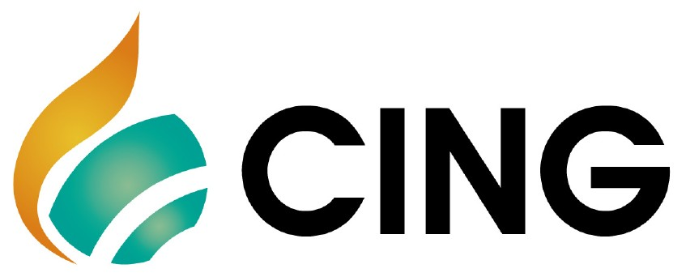
E-mail: Contact：
Application Form
The 16th Beijing International Natural Gas Technology & Equipment Exhibition
Date:March 26th -28th ,2026 Venue: China International Exhibition Center (Shunyi Hall), Beijing
Please fill out the form below and then send it back to the organizer via fax or email.
Company Name:
Address: Country: Postal/Zip code:
Contact (Mr. / Ms.): Position:
Mobile: TEL: FAX:
Website: E-mail:
Main products/exhibits (English):
Exhibition Space
□ Shell scheme: SQM (CNY30, 000 / 9sqm)
Preferred booth numbers: Fee:
- Raw space: SQM (CNY3, 200 / SQM minimum 36 SQM)
Preferred booth numbers: Fee:
Sponsorship & Advertisement
- Exhibition Catalogue Ad.
□Front Cover CNY36,000 □Inside Front Cover CNY25,000 □Head Page CNY25,000 □Back Cover CNY30,000 □Inside Back Cover CNY22,000 □Colored Inside Page CNY12,000
- Show Daily:
□ Full page US$19,375 per insertion □Half page US$9,688 per insertion
- Technical Seminar
□Technical Seminar CNY12,000/Session
□New Product/Technology Promotion Session CNY32,000/30minutes
- Exclusive Sponsor
□Banquet Sponsor: CNY360,000 □Gift Sponsor: CNY300,000
□Visitor Guide Front Cover: CNY180,000 Visitor Guide Back Cover: CNY96,000
□ Media Promotion
□Pre-show Promotion: CNY 2,000/time □Post-show Promotion: CNY 2,000/time
□During the show promotion: CNY 7,000/time
□ Photography Service
□Photography and video CNY6,000/day
□ Live Broadcasting
□cippe Discoveries Livestream CNY5,000/session □Customized live broadcasting CNY50,000/day
□ Additional Exhibitor Service CNY 1,200/person Person(s)
Total fee: Payment Date:
Special Attention:
1.Please remit the total participation fee to the account appointed by the organizer within 10 business days upon receipt the confirmation letter; 2. Booking received without this deposit will not be confirmed; 3.The payment cannot be refunded if the registered exhibitors do not exhibit for its own reason; 4.The exhibiting products should meet the exhibit scope and theme, and should not infringe intellectual property rights, otherwise the exhibitors should bear the full legal responsibility. 5. Exhibitors must choose the contractor designated by the organizer, others are not allowed to enter the venue.
Beijing Zhenwei Exhibition Co., Ltd.  Tel:+86-10-  Fax: +86-10-5617 6998  E-mail:  Contact: | Company Name:  Signature & Stamp:

CING2026 Target Visitors Programme

Exhibitor Name
Website
Company Profile
Products & Technology to be Showcased
What kind of companies you are keenly interested in meeting at CING2026?
Please name some companies you haven’t established business relations but hope to meet at CING2026(the more the better).
Please name some companies you are already in cooperation with and hope to meet at CING2026(the more the better).
Note: If the companies you would like to meet are giants like CNPC, SINOPEC, etc. Please name the branch name, departments or main business.

