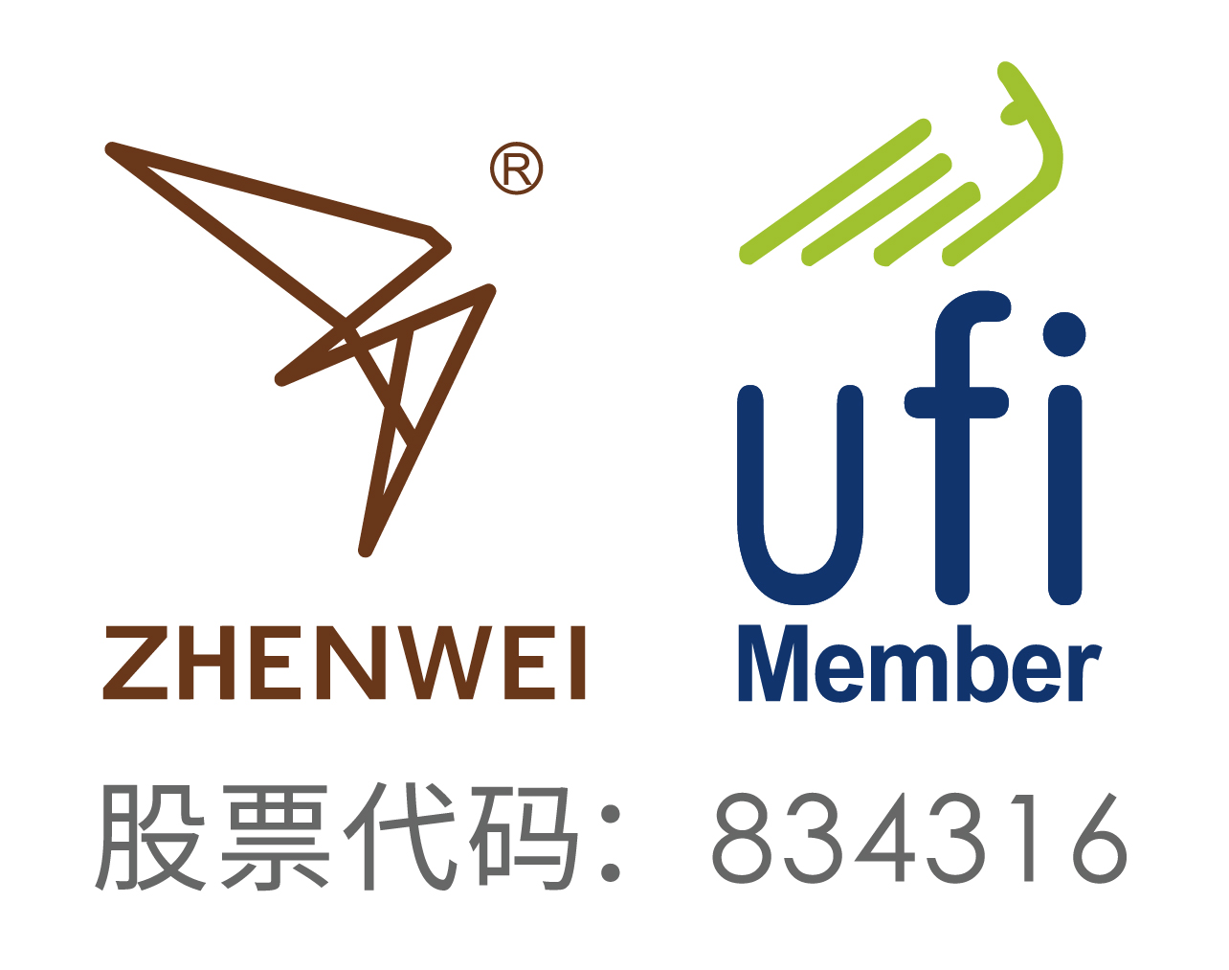
INVITATION
To： From:


2026 Beijing International Gas Applications and Technical Equipment Exhibition

March 26th-28th, 2026
China International Exhibition Center (Shunyi Hall), Beijing
2,000 Exhibitors from 81 Countries and Regions
52 Exhibitors from Fortune Global 500
18 National Pavilions
120,000m² Exhibition Space
180,000 Professional Visitors

Organizer
Zhenwei International Exhibition Group
Beijing Zhenwei Exhibition Co., Ltd.

Brief Introduction
As the prominent form of natural gas consumption, gas plays an important role in the application of China's clean energy, and has become an indispensable daily necessities for people's daily life. With the acceleration of China's urbanization process, city gas planning has become an important part of modern urban construction planning. In the future, gas will play a more important role in power generation and heating, and realize its application in rural areas, increase the proportion of gas in energy consumption structure, and finally realize the vision of a beautiful China.
2026 Beijing International Gas Applications and Technical Equipment Exhibition will be held to provide an efficient platform for showcasing the latest technical equipment and service solutions in the gas field, networking and expanding business exchanges. With an exhibition space of 120,000sqm, it is expected to attract 2,000+ exhibitors, 18 international pavilions and 180,000+ person-time professional visitors from 81 countries and regions.
Welcome to participate in.

Range of Exhibits
Gas Transmission & Distribution and Maintenance
Gas Management and Application Technology
Gas Control and Detection Technology and Equipment
Gas Valve and Automatic Control System

Gas Metering Equipment and Alarm System
City Gas Information Management System and Software
Gas Special Pipes and Equipment
Gas Heating, Gas-Driven Central HVAC

Pipeline Anti-Corrosion
Underground Pipeline Detection and Leakage Monitoring
Gas Boiler and Heating (Water) Equipment
Appliances and Spare Parts

Co-located Exhibitions

cippe | The 26th China International Petroleum & Petrochemical Technology and Equipment Exhibition
Offshore | The 26th Beijing International Offshore Oil & Gas Exhibition
Pipeline | The 26th Beijing International Oil & Gas Pipeline, Storage and Transportation Exhibition
Natural Gas | The 16th Beijing International Natural Gas Technology & Equipment Exhibition
Marine | The 16th Beijing International Offshore Engineering Technology & Equipment Exhibition
Hydrogen | 2026 Beijing International Hydrogen Technology & Equipment Exhibition
Trenchless | Beijing International Underground Engineering Construction & Trenchless Exhibition
QHSE | Beijing International petroleum and Petrochemical Safety Production Exhibition

Exhibition Schedule
Registration & Setting up: | March 24-25, 2026
Exhibition Opening: | March 26-28, 2026
Closing & Dismantling: | Begin at 14:00pm, March 28, 2026

Exhibiting Costs
Exhibition Space | Shell Scheme:  Price: CNY 30,000/9SQM (W1、W2); Regular size: 3m×3m.  This option includes back & inside walls, carpet, lintel board, one consulting table, two chairs, two lights and one power socket (220V, 5A).
Exhibition Space | Raw Space:  Price: CNY 3,200/SQM. (Mini.36sqm) (W1、W2).  Empty exhibition space for exhibitor to customize booth design and construction. The exhibitors shall not choose a contractor that which is not appointed to design and or construct their special design.
Exhibitor Service | Additional Exhibitor Service  Price: CNY 1,200/person (It includes lunches, beverages, opening banquet, gifts, etc.)
Exhibition Catalogue Ad. | Front Cover: CNY 36,000 Inside Back Cover: CNY 22,000  Back Cover: CNY 30,000 Head Page: CNY 25,000  Inside Front Cover: CNY 25,000 Colored Inside Page: CNY 12,000
Technical Seminar | A series of technical seminars will be held during the exhibition so as to maximally meet participants’ requirements for technical communication and products launch as well.  Technical Seminar (Conference Room)  Price: CNY12,000/Session  New Product/Technology Promotion Session (Exhibition Hall Seminar Area)  Price: CNY32,000/30minutes
Exclusive Sponsor | Banquet Sponsor: CNY360,000  With around 600 participants, including VIPs, exhibitors, conference delegates, industrial leaders and professional purchasers, etc., the Banquet will offer you with an excellent opportunity for market campaign.  Gift Sponsor: CNY300,000  All the sponsored gifts will be distributed to VIP guests. It is an efficient way to show the strength of the sponsor, to promote brand awareness and to enhance market position as well.  Visitor Guide Sponsor: CNY96,000 (Back cover advertisement)
Media Promotion | Pre-show Promotion: CNY 2,000/time  Post-show Promotion: CNY 2,000/time  During the show promotion: CNY 7,000/time
Photography Service | Photography and video  Price: CNY6,000/day
Live Broadcasting | Exhibition visiting live broadcasting  Price: CNY5,000/session (5-20minutes)
Live Broadcasting | Customized live broadcasting  Price: CNY50,000/day
More Sponsorship Opportunities, please contact with the GAS Organizing Committee.

Organizer: Zhenwei International Exhibition Group
Beijing Zhenwei Exhibition Co., Ltd.
Add: Zhenwei Exhibition Building, Building III13, International Enterprise Avenue, Yard 1, Jinghai 5th Road, Tongzhou District, Beijing
Tel: +86-10-5617 Fax: +86-10-5617 6998
Mob: http: // www.cingexpo.com.cn
- mail: Contact：



Application Form
2026 Beijing International Gas Applications and Technical Equipment Exhibition
Date: March 26th -28th,2026 Venue: China International Exhibition Center (Shunyi Hall),Beijing
Please fill out the form below and then send it back to the organizer via fax or email.
Company Name:
Address: Country: Postal/Zip code:
Contact (Mr. / Ms.): Position:
Mobile: TEL: FAX:
Website: E-mail:
Main products/exhibits (English):
Exhibition Space
□ Shell scheme: SQM (CNY30, 000 / 9sqm)
Preferred booth numbers: Fee:
- Raw space: SQM (CNY3, 200 / SQM minimum 36 SQM)
Preferred booth numbers: Fee:
Sponsorship & Advertisement
- Exhibition Catalogue Ad.
□Front Cover CNY36,000 □Inside Front Cover CNY25,000 □Head Page CNY25,000 □Back Cover CNY30,000 □Inside Back Cover CNY22,000 □Colored Inside Page CNY12,000
- Show Daily:
□ Full page US$19,375 per insertion □Half page US$9,688 per insertion
- Technical Seminar
□Technical Seminar CNY12,000/Session
□New Product/Technology Promotion Session CNY32,000/30minutes
- Exclusive Sponsor
□Banquet Sponsor: CNY360,000 □Gift Sponsor: CNY300,000
□Visitor Guide Front Cover: CNY180,000 Visitor Guide Back Cover: CNY96,000
□ Media Promotion
□Pre-show Promotion: CNY 2,000/time □Post-show Promotion: CNY 2,000/time
□During the show promotion: CNY 7,000/time
□ Photography Service
□Photography and video CNY6,000/day
□ Live Broadcasting
□cippe Discoveries Livestream CNY5,000/session □Customized live broadcasting CNY50,000/day
□ Additional Exhibitor Service CNY 1,200/person Person(s)
Total fee: Payment Date:
Special Attention:
1.Please remit the total participation fee to the account appointed by the organizer within 10 business days upon receipt the confirmation letter; 2. Booking received without this deposit will not be confirmed; 3.The payment cannot be refunded if the registered exhibitors do not exhibit for its own reason; 4.The exhibiting products should meet the exhibit scope and theme, and should not infringe intellectual property rights, otherwise the exhibitors should bear the full legal responsibility; 5. Exhibitors shall not choose a contractor that is not designated by the organizer to set up their booths.
Beijing Zhenwei Exhibition Co., Ltd.  Tel: +86 10 5617 6968/58  E-mail:  Contact: | Company Name:  Signature & Stamp:

GAS2026 Target Visitors Programme

Exhibitor Name
Website
Company Profile
Products & Technology to be Showcased
What kind of companies you are keenly interested in meeting at GAS2026? | e.g. oil and gas field units, oil production plants, exploration and development companies, drilling engineering companies, etc.
Please name some companies you haven't established business relations but hope to meet at GAS2026 (the more the better).
Please name some companies you are already in cooperation with and hope to meet at GAS2026 (the more the better).
Note: If the companies you would like to meet are giants like CNPC, SINOPEC, etc. Please name the branch name, departments or main business.

