**INVITATION**

|  |
| --- |
| To： From： |

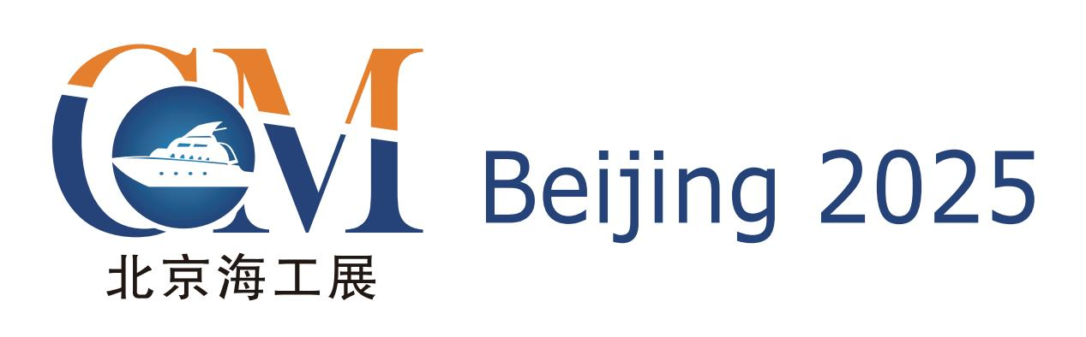

**The 15th Beijing** **International Offshore**

**Engineering Technology & Equipment Exhibition**

**March 26-28, 2025 New China International Exhibition Center, Beijing**

**The Leading Offshore Event in Asia**

**Hosted by**

China Association of the National Shipbuilding Industry

China Association of Oceanic Engineering

The Chinese Society of Naval Architects and Marine Engineers

China Shipowner’s Association

Zhenwei International Exhibition Group

**Organized by**

Beijing Zhenwei Exhibition Co., Ltd.



|  |
| --- |
| **Concurrent Exhibitions:**  cippe ciooe CIPE CING Expec cisge |

***Exhibition*** ***Profile***

The 15th Beijing International Offshore Engineering Technology & Equipment Exhibition (CM 2025) will be held on March 26-28,2025 at NCIEC, Beijing.

Concurrently held with China International Petroleum & Petrochemical Technology and Equipment Exhibition(cippe).CM2025 is one of the most influential and comprehensive exhibitions, covering offshore engineering, offshore oil and gas, onshore oil and gas. It welcomed 2,000 exhibitors, 18 National Pavilions and 150,000 professional visitors from 65 countries and regions worldwide in the year of 2024, achieving an exhibition floor space of above 120,000 square meters.

CM2024 had an attendance of 18 international pavilions from USA, Germany, UK, France, Canada, Denmark, Italy, Russia, Korea etc. The well-known enterprises of ExxonMobil, Rosneft. Schlumberger, Bake Hughes, DNV/GL, RS, National Oil Varco, Caterpillar, MTU, Cummins, GE, Schneider, Honeywell, [Atlas](http://dict.youdao.com/w/Atlas/" \l "keyfrom=E2Ctranslation), Huisman, API, 3M, E+H, ARIEL, KSB, PPG, Hempel, International Maritime Services, have all participated in the event.

Moreover, CM2024 has received great support from the domestic exhibitors, such as CNPC Pavilion, Sinopec Oil Engineering Machinery Company, CNOOC, CSSC, CCS, CIMC RAFFLES,RG Petro-machinery (Group) Co.,Ltd, HONGHUA, JEREH, KERUI, SANY, Tidfore, L&H, JULI Sling, HBP,Tidfore, JERRYWON,Ocean King Lighting,Douson Group, ANTON, JUNMA, SHENKAI, Tianjin LILIN and etc.

The professional buyers are from CNPC, SINOPEC, CNOOC, Overseas Project Department of CNODC, China Petrolum Pipeline Bureau, Sinotrans & CSC Holdings Co. Ltd, COSCO, BP, Saudi Aramco, Shell, Total, Gazprom, Rosneft, ConocoPhillips, Statoil, Petrobras, Schlumberger, Bake Hughes, Halliburton, Weatherford, Transocean,Chevron, etc,together with many other professional visitors from Brazil, Ukraine, Malaysia, Sudan, Nigeria and so on.

Marine engineering equipment is one of the key sectors identified in 'Made in China 2025’, which is an important part of China's strategic emerging industries and the key direction of high-end equipment manufacturing. It is an important foundation and support for China to implement its maritime power strategy. The proposals for formulating the 14th Five-Year Plan (2021-2025) clearly stated that we should adhere to the overall planning of land and sea, develop marine economy, and accelerate the nation's progress in becoming a maritime power; improve the development and protection of marine resources and mineral resources, and develop strategic emerging industries.

Aiming at utilizing the international vision of Beijing, creating a highly efficient platform for showcasing the latest technologies and products in offshore engineering industry, connecting buyers with suppliers, and assisting exhibitors in exploring business opportunities in China and world market, CM will successfully bridge you to China’s offshore engineering industry. Let us set sail on a successful journey with CM Beijing 2025—the great event that you do not want to miss out!

***Who Should Exhibit***

(If you are a supplier of any of the products or service shown below, please book a stand right away)

* Offshore oil & gas exploration, exploit and production equipment
* Offshore geophysical exploration , well logging and drilling
* Offshore drilling platform associated equipment
* Classification Society
* Offshore platform module
* Oil and gas storage and transport equipment
* Design, research institute
* Oilfield services
* Work boat and offshore support vessel
* LNG/LPG/LEG ship
* Power and control equipment
* Steel structure
* Explosion- proof equipment
* Electrical & electronic instruments
* Pipelines, valve, pump
* Examination, repair, maintenance and management equipment
* Fire and alarm equipment,articles for safety and labor protection
* Special vehicle, helicopter and drone
* Technology and material for anti- corrosion
* Technology and equipment for ocean wind power
* Ocean exploration, underwater processing
* Water treatment technology and equipment
* Flammable ice exploration, exploit technology and equipment
* Environment protection and safety
* Marine new materials
* Remote detection
* Communication, Management information system
* Publication/Technical/Training

***Technical Seminar***

A series of technical seminars will be held during the exhibition so as to maximally meet participants’ requirement for technical communication and products launch, as well. Each seminar lasts for one hour and cost CNY 12,000 which includes the expenses of meeting room and the rents of relevant equipment.

***Exhibition Costs***

|  |  |
| --- | --- |
| **Exhibition Space** | **Shell Scheme:**  Price: CNY 30,000/9SQM; Regular size : 3m×3m.  This option includes back & inside walls, carpet, lintel board, one consulting table, two chairs, two lights and one power socket (220V, 5A). |
| **Raw Space:**  Price: CNY 3,200/SQM. (Mini.36sqm).  Empty exhibition space for exhibitor to customize booth design and construction. The exhibitors shall not choose a contractor that which is not appointed to design and or construct their special design. |
| **Exhibitor Service** | **Additional Exhibitor Service**  Price:CNY 1,200/person (It includes lunches, beverages, opening banquet, gifts, etc.) |
| **Exhibition Catalogue Ad.** | **Front Cover**: CNY 36,000 **Inside Back Cover**: CNY 22,000 **Back Cover**: CNY 30,000 **Head Page**: CNY 25,000 **Inside Front Cover**: CNY 25,000 **Colored Inside Page**: CNY 12,000 |
| **Technical Seminar** | A series of technical seminars will be held during the exhibition so as to maximally meet participants’ requirements for technical communication and products launch as well.  **Technical Seminar** (Conference Room)  Price: CNY12,000/Session  **New Product/Technology Promotion Session** (Exhibition Hall Seminar Area)  Price: CNY32,000/30minutes |
| **Exclusive Sponsor** | **Banquet Sponsor:** CNY360,000  With around 600 participants, including VIPs, exhibitors, summit delegates, industrial leaders and professional purchasers, etc., the Banquet will offer you with an excellent opportunity for market campaign.  **Gift Sponsor:** CNY300,000  All the sponsored gifts will be distributed to VIP guests. It is an efficient way to show the strength of the sponsor, to promote brand awareness and to enhance market position as well.  **Visitor Guide Sponsor:** CNY960,000(Back cover advertisement) |
| **Media Promotion** | **Pre-show Promotion**: CNY 2,000/time  **Post-show Promotion**: CNY 2,000/time  **During the show promotion**: CNY 7,000/time |
| **Photography Service** | **Photography and video**  Price: CNY4,000/day |
| **Live Broadcasting** | **Exhibition visiting live broadcasting**  Price: CNY2,000/session (5-20minutes) |
| **Customized exhibition live broadcasting**  Price: CNY50,000/day |

More Sponsorship Opportunities, please contact with the CM organizational committee.



Organizer:Beijing Zhenwei Exhibition Co.,Ltd

Add: Zhenwei Exhibition Building, Building III13, International Enterprise Avenue, Yard 1, Jinghai

5th Road, Tongzhou District, Beijing

Tel: +86-10- 56176945 Fax: +86-10-5617 6998

Web: [www.chinamaritime.com.cn](http://www.chinamaritime.com.cn/) E-mail: [cm@zhenweiexpo.com](mailto:wy@zhenweiexpo.com)

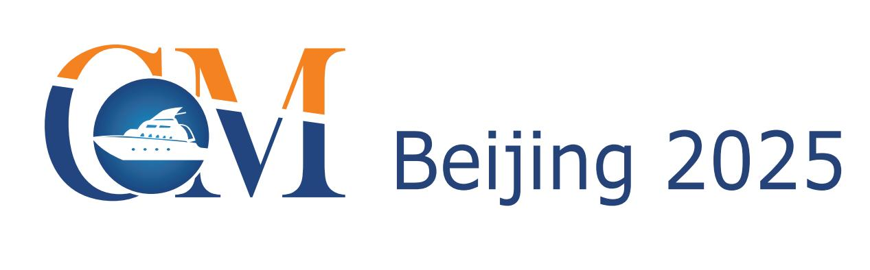**APPLICATION FORM**

**The 15th Beijing International Offshore Engineering Technology & Equipment Exhibition**

**March 26-28, 2025 New China International Exhibition Center, Beijing**

Please fill out the form below and then send it back to the organizer via fax or e-mail.

Company Name:

Address: Country: Postal/Zip code:

Contact (Mr. / Ms.): Position:

Mobile: TEL: FAX:

Website: E-mail:

Main products/exhibits (English):

**Exhibition Space**

□ Shell scheme: SQM (CNY30, 000 / 9 SQM)

Preferred booth numbers: Fee:

* Raw space: SQM (CNY3, 200 / SQM minimum 36 SQM)

Preferred booth numbers: Fee:

**Sponsorship & Advertisement**

|  |
| --- |
| * Exhibition Catalogue Ad.   □Front Cover CNY36,000 □Inside Front Cover CNY25,000 □Head Page CNY25,000 □Back Cover CNY30,000 □Inside Back Cover CNY22,000 □Colored Inside Page CNY12,000   * Technical Seminar   □Technical Seminar CNY12,000/Session  □New Product/Technology Promotion Session CNY32,000/30minutes   * Exclusive Sponsor   □Banquet Sponsor: CNY360,000 □Gift Sponsor: CNY300,000  □Visitor Guide Sponsor: CNY960,000  □ Media Promotion  □Pre-show Promotion: CNY 2,000/time □Post-show Promotion: CNY 2,000/time  □During the show promotion: CNY 7,000/time  □ Photography Service  □Photography and video CNY4,000/day  □ Live Broadcasting  □Exhibition visiting live broadcasting CNY5,000/session  □Customized exhibition live broadcasting CNY50,000/day  □ Additional Exhibitor Service CNY 1,200/person Person(s) |

**Total fee:**   **Payment Date:**

**Special Attention:**

|  |  |
| --- | --- |
| **Beijing Zhenwei Exhibition Co., Ltd.**  **Tel:** +86 10 5617 6945  **E-mail:** cm@zhenweiexpo.com  **Contact:** CM | **Company Name:**    **Signature & Stamp:** |

1.Please remit the total participation fee to the account appointed by the organizer within 10 business days upon receipt the confirmation letter; 2. Booking received without this deposit will not be confirmed; 3.The payment cannot be refunded if the registered exhibitors do not exhibit for its own reason; 4.The exhibiting products should meet the exhibit scope and theme, and should not infringe; 5.intellectual property rights, otherwise the exhibitors should bear the full legal responsibility.

**CM 2024 Target Visitors Programme**

|  |  |
| --- | --- |
| Exhibitor Name |  |
| Website |  |
| Company Profile |  |
| Products & Technology to be Showcased |  |
| What kind of companies you are keenly interested in meeting at CM2025? | e.g. oil and gas field units, oil production plants, exploration and development companies, drilling engineering companies, etc. |
| Please name some companies you haven’t established business relations but hope to meet at CM2025 (the more the better). |  |
| Please name some companies you are already in cooperation with and hope to meet at CM2025 (the more the better). |  |

**Note:** If the companies you would like to meet are giants like CNPC, SINOPEC, etc. Please name the branch name, departments or main business.