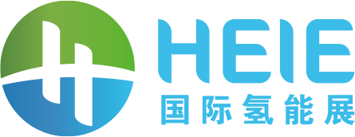
2022 Beijing International Hydrogen Technology & Equipment Exhibition & Hydrogen Energy Summit
Invitation

About HEIE
Hydrogen, as an efficient, clean and sustainable “carbon-free” energy, has gained worldwide attention, dubbed as the 21st-century energy source. In recent years, over 30 countries and regions including China, US, Japan, Korea, Canada and EU members, etc. have developed roadmap for hydrogen growth. In view of the latest energy strategic development landscape, hydrogen energy will account for 10% - 15% of China's terminal energy system by 2050, constituting a most significant part of China’s energy strategy.
In China, there have been nearly 30 provinces (including prefecture level cities) incorporating hydrogen into the 14th Five-Year Plan with policy guidance surpassed 150 drafts . Meanwhile, the industry has gained preference by financial institutions since 2021, and the hydrogen-craze is increasingly heating up. Expectedly the total investment would exceed CNY 300 billion by 2022, making stride to a value of trillion industry, as the country is ramping up efforts in terms of policy mechanisms.
Beijing International Hydrogen Technology & Equipment Exhibition (HEIE), organized by Beijing Zhenwei Exhibition Co., Ltd., will be held through July 6-8, 2022 at New China International Exhibition Center, Beijing. HEIE covers areas such as hydrogen production, storage, transportation, refueling and monitoring; fuel cells and components, hydrogen fuel vehicles, etc., aiming to build a top international platform for technological exchanges and innovations in the holistic hydrogen industry chain. Welcome to join us.

Zhenwei International Exhibition Group
Beijing Zhenwei Exhibition Co., Ltd.
5 January 2022

